**Margins Top 2.57, Bottom 1.09, Left 1.75, Right 1.5**

**Paper Title (Times New Roman, Bold, font size 16, left justified)**

**Author1,**

**Author2**

**Author3**

**Author4**

**:**

**and Author8**

1Department …………………., Institute/University, Country

2Department …………………., Institute/University, Country

3Department …………………., Institute/University, Country

4Department …………………., Institute/University, Country

:

8Department …………………., Institute/University, Country

**Abstract (Times New Roman, Bold, font size 12, left justified)**

This study investigates the potential influence of blockchain technology on the energy sector, as well as the opportunities it may present for energy customers and consumers. Blockchain, which began as a niche product on the outskirts of the market, has been attracting the attention of specialists in a variety of industries for some time now, and has been increasingly in the limelight of the media. …………………………….. ……………. …………….. ………. ………… …………….. . ………. ……………. ………….. …. (Times New Roman, justified, font size 10) ……………………………………………………………………….

 Corresponding Author’s Email: [abc@gmail.com](mailto:abc@gmail.com). (Times New Roman, justified, font size 10)

In: 10th International Conference on Research Innovations – Trends in Computational Science

Editors: Rajendra Kumar, et al.

ISBN: 979-8-XXXX-XXX-X

© 2025 Nova Science Publishers, Inc.

…………………………………………………… Smart contracts that manage the system and distributed ledgers that securely record all activities would have a direct impact on network and storage operations.

**Keywords:** smart grid, blockchain, IoT, ICT, energy (Times New Roman, justified, font size 10)

# Introduction (Times New Roman, left justified, font size 12)

Blockchain, an online ledger to store information securely, acts as a publicly accessible knowledge repository. Blockchain is a distributed ledger that uses data logging to ensure that the data cannot be altered or distorted by anyone else. ………… (Times New Roman, justified, font size 10) ……………..

There will be cost variations between private and public blockchains, as shown in Figure 1. Private blockchains typically have lower transaction costs and use more straightforward verification techniques (for example, proof-of-work confirmation consumes more energy than proof-of-stake verification), lowering expenses (Daj, 2016) (Reference and Citation in APA style, Times New Roman, font size 10)

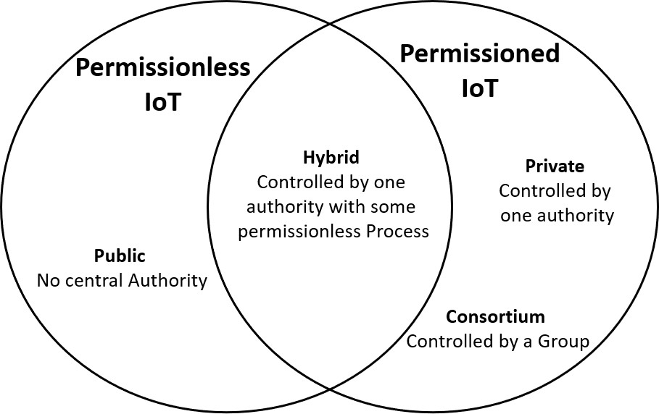

**Figure 1.** Public and private blockchains. (Times New Roman, left justified, font size 9)

All costs must account for the investments needed to have electricity systems with added flexibility: blockchain may only be utilized effectively if…………… (Beier et al, 2018)

# Literature Review

# 

# Methodology

# Experiments

# Results and Discussion

# Conclusion

Blockchain implementation in commercial applications is still in its early stages, which involves several unknowns and hazards associated with it. There is no long-term experience beyond the Bitcoin context as a highly recognized blockchain application to date. ……………………… ……………………. ………………………… ……………………. ………………… ……. ………………………………… ………………………………………… …….

# References (Times New Roman, left justified, font size 12)

(Times New Roman, justified, font size 9, APA format)

Araral, E., 2020. “Why do Cities Adopt Smart Technologies? Contingency Theory and Evidence from the United States.” *Cities* 106, 1-15.

Beier, G., Niehoff, S., Xue, B., 2018. “More Sustainability in Industry Through Industrial Internet of Things?” *Applied Sciences* 8 (2): 1-12.

Beringer, A., Adombent, M., 2008. “Sustainable University Research and Development: Inspecting Sustainability in Higher Education Research.” *Environmental Education Research* 14 (6): 607-623.

Cătoiu, I., Vrânceanu, D. M., Filip, A., 2010. “Setting Fair Prices - Fundamental Principle of Sustainable Marketing.” *Amfiteatru Economic* 12 (27): 115-129.

Daj, A., 2016. “Economic and Technological Aspects of Using IoT for Sustainable Environment Management. The case of IoT Wildfire Detection Systems.” *Bulletin of the Transilvania University of Braşov* 5: 171-184.

Dietz, T., Rosa, E., York, R., 2009. “Environmentally Efficient Well-Being: Rethinking Sustainability as the Relationship between Human Well-being and Environmental Impacts.” *Human Ecology Review* 16 (1): 114-123.